LAB EXPERIMENTS

NAME: K. DEVI POOJITHA
REG.NO:192565052

- Write the python program to solve 8-Puzzle problem

Python code:

from collections import deque

s=input("Enter puzzle: ") q=deque([(s,[])])
v={s}

while q:

x,p=q.popleft()

if x=="123456780":

print("Solution:") for a in p+[x]:
print(a[:3]);print(a[3:6]);print(a[6:]);print() break
i=x.index("0")

for j in [i-3,i+3,i-1,i+1]:

if 0<=j<9 and abs(i%3-j%3)<=1: a=list(x);a[i],a[j]=a[j],a[i];a=''.join(a)
if a not in v:v.add(a);q.append((a,p+[x]))

else:

print("No solution")

Output:
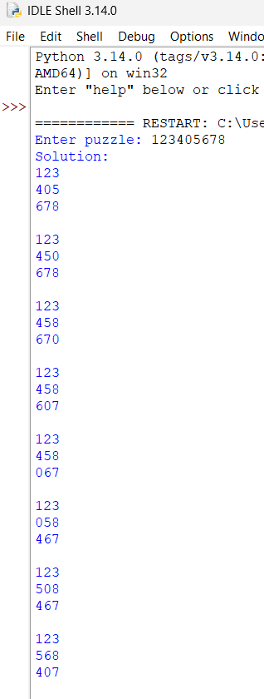
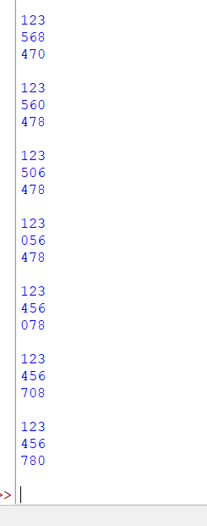

2.Write the python program to solve 8-Queen problem

Python code:

def solve(r, q): if r == 8:
for i in range(8):

print(" ".join("Q" if q[i] == j else "." for j in range(8))) return True
for c in range(8):

if c not in q and all(abs(c-x) != r-i for i,x in enumerate(q)): if solve(r+1, q+[c]):
return True return False

solve(0, [])

Output:
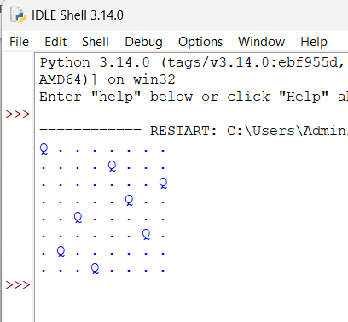

- Write the python program for Water Jug Problem

Python code:

a = 0

b = 0 print(a, b)

while a != 2: if a == 0:
a = 4 elif b == 3:
b = 0 else:
x = min(a, 3-b)

a = a-x

b = b+x print(a, b)

Output:

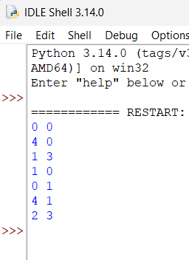

- Write the python program for Missionaries Cannibal problem

Python code:

from collections import deque

q = deque([((3,3,1), [])]) v = {(3,3,1)}
moves = [(1,0),(2,0),(0,1),(0,2),(1,1)]

while q:

(m,c,b), p = q.popleft()

if (m,c,b) == (0,0,0):

for x in p + [(m,c,b)]: print(x)
break

for dm,dc in moves:

nm = m-dm if b else m+dm nc = c-dc if b else c+dc

nb = 1-b

if 0<=nm<=3 and 0<=nc<=3:

if (nm==0 or nm>=nc) and (3-nm==0 or 3-nm>=3-nc): s=(nm,nc,nb)
if s not in v:

v.add(s); q.append((s,p+[(m,c,b)]))

Output:
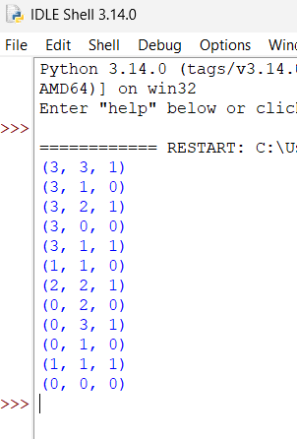

- Write the python to implement Travelling Salesman Problem

Python code:

from itertools import permutations

d=[[0,10,15,20],[10,0,35,25],[15,35,0,30],[20,25,30,0]
best=999 path=None

for p in permutations(range(1,4)): r=(0,)+p+(0,)
cost=sum(d[r[i]][r[i+1]] for i in range(4)) if cost<best:
best=cost path=r

print("Path:",path) print("Minimum cost:",best) Output:
